

EMAIL TEMPLATE STYLE 1

Although the Houston Methodist email templates have been placed into Microsoft Word documents, they are created for use with Microsoft Outlook. Please read through the following instructions in order to properly use the templates.

Note: All email blast must be brand compliant and should adhere to HM’s email standards.

Instructions
The email template has been built using a table in order to enable text wrapping. All text and images should be inserted into a table cell. For more information on inserting images in tables, visit this Microsoft tutorial.

1. Format your email in Microsoft Word using the Franklin Gothic font family.
2. Highlight all text between the header and the footer, including any images, and under paragraph, set the left and right indentation to 0.1”. This will indent the text on both sides so that there is a margin within the white area.
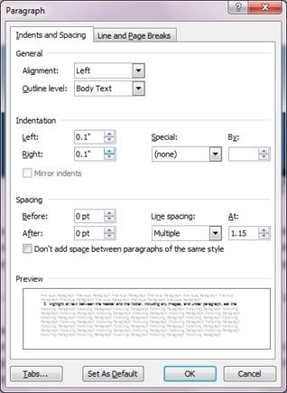
3. Copy the entire table and paste it into a new Microsoft Outlook email.
4. In Outlook, place your cursor into the body of the text and select the entire cell paste option under paste. If that option is not available under paste options, select keep source formatting (E).
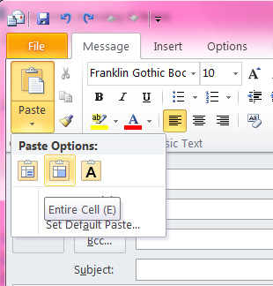
5. Change the page color of the email to the second lightest gray so that the e-blast does not appear to be floating.

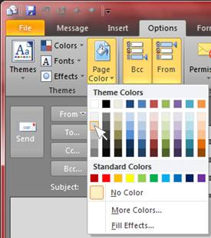

Tips:
If you have an email signature that automatically appears and you are sending out an e-blast on behalf of someone else, remember to remove your email signature information.

Hold down the SHIFT key when resizing images so the images appear proportionate and not skewed.

Remember to change the entity name, address and phone number in the footer, if appropriate.

Houston Methodist Cypress Hospital | 24500 Northwest Fwy., Cypress, TX 77429 | 713.790.3333

